**DOCUMENT-1**

**Mid Evaluation**

|  |  |  |
| --- | --- | --- |
| Title: Smart Restaurant System | | |
| Class/Section:  ME (Internet of Things) | Register Number | Name |
| 181048014 | Chethan M |
| 181048015 | Rohith M |

**GUIDE: RAGHAVENDRA PRABHU**

**ABSTRACT:**

The art of technology from reservation to ordering and storing customer records is the concept of Smart restaurant. The project mainly aims in designing completely automated menu and delivery of order to the customer table in restaurants with the help of Android mobile phone application or through website and conveyor belts. There is no need of a person to take the order from the table. The menu will be displayed on the customer mobile application and they can directly order from the displayed menu. The system calculates and displays the final bill based on the placed order. Efficient and low-cost design methodology. Smart Restaurant is developed to provide an easy interaction between the customers through wireless technology.

Key words:

**Literature Survey:**

The journey for getting up to the peak of joy and facilities that we are presently experiencing started with initial footstep of a wireless technology. The introduction of basic proposed systems and consequent developments are being mentioned below:

* Khairunnisa K. proposed the application of wireless food ordering system. This work presented in depth on the technical operation of PDA based Wireless Ordering System (WOS) including systems architecture, function, limitations and recommendations.
* N. M. Z. Hashim presented an approach to develop a system by introducing the integration of Bluetooth

technology as the communication medium and Peripheral Interface Controller (PIC) as the hardware

which implemented faster ordering system.

* Sushmita Sarkar presented the integration of touch technology in restaurants using android. This system was a basic dynamic database utility system which fetches all information from a centralized database. The tablet at the customer table contains the android application with all the restaurant and menu details.
* A conveyor system for restaurants consists of a plurality of tray-supporting carriages which are electrically driven to move along a track system including rails from which they derive their power.

**OBJECTIVES:**

* Usage of Android application in performing the task.
* No need of a waiter to take order from the table and to serve quickly.
* Efficient and low-cost design.
* Smart Restaurant is developed to provide an easy interaction between the customers through wireless technology.

**INTRODUCTION:**

The increase in the number of industries to use electronic media and application for information exchange is the advancement of Information and Communication Technology. In the restaurant sector, Personal Digital Assistant has been adopted to replace the conventional way of placing orders using pen and paper. The PDA based food ordering system has some limitations such as the requirement of training of attendants, the need of having attendants to operate, the inefficiency during peak hours and small screen size. PDA limitations are overcome by introducing an application loaded in an android Smart phone or tablet containing the menu details.

Android is a software stack for mobile devices that includes an operating system, middle-ware and key applications. Android boasts a healthy array of connectivity options, including Wi-Fi, Bluetooth, and wireless data over a cellular connection. Android consists of a full set of tools that has been built from the ground up alongside the platform providing developers with high productivity and deep insight into their applications. Once the order is placed, the chef gets the details such as customer table and items that has been ordered. The chef prepares and place the order on the conveyor belt and it will be delivered to the customer which will be specified by the chef.

The project mainly aims in designing completely automated menu and delivery of order to the customer table in restaurants with the help of Android mobile phone application or through website and conveyor belts. There is no need of a person to take the order from the table. The menu will be displayed on the customer mobile application and they can directly order from the displayed menu.

**METHODOLOGY:**

The art of technology from reservation to ordering and storing customer records is the concept of Smart restaurant. An Android application helps the customer to view the fully automated menu ordering system. The ordering process is carried out by scanning the QR code on the reservation table and is used to handle the delivery activity. The order is rooted to the kitchen via a central server. The kitchen having a direct interface displays the order and services based on their priority (first come first serve). The food delivery is carried out through the conveyor belt to the ordered table number. The payment is done by scanning the QR code.

**BLOCK DIAGRAM:**

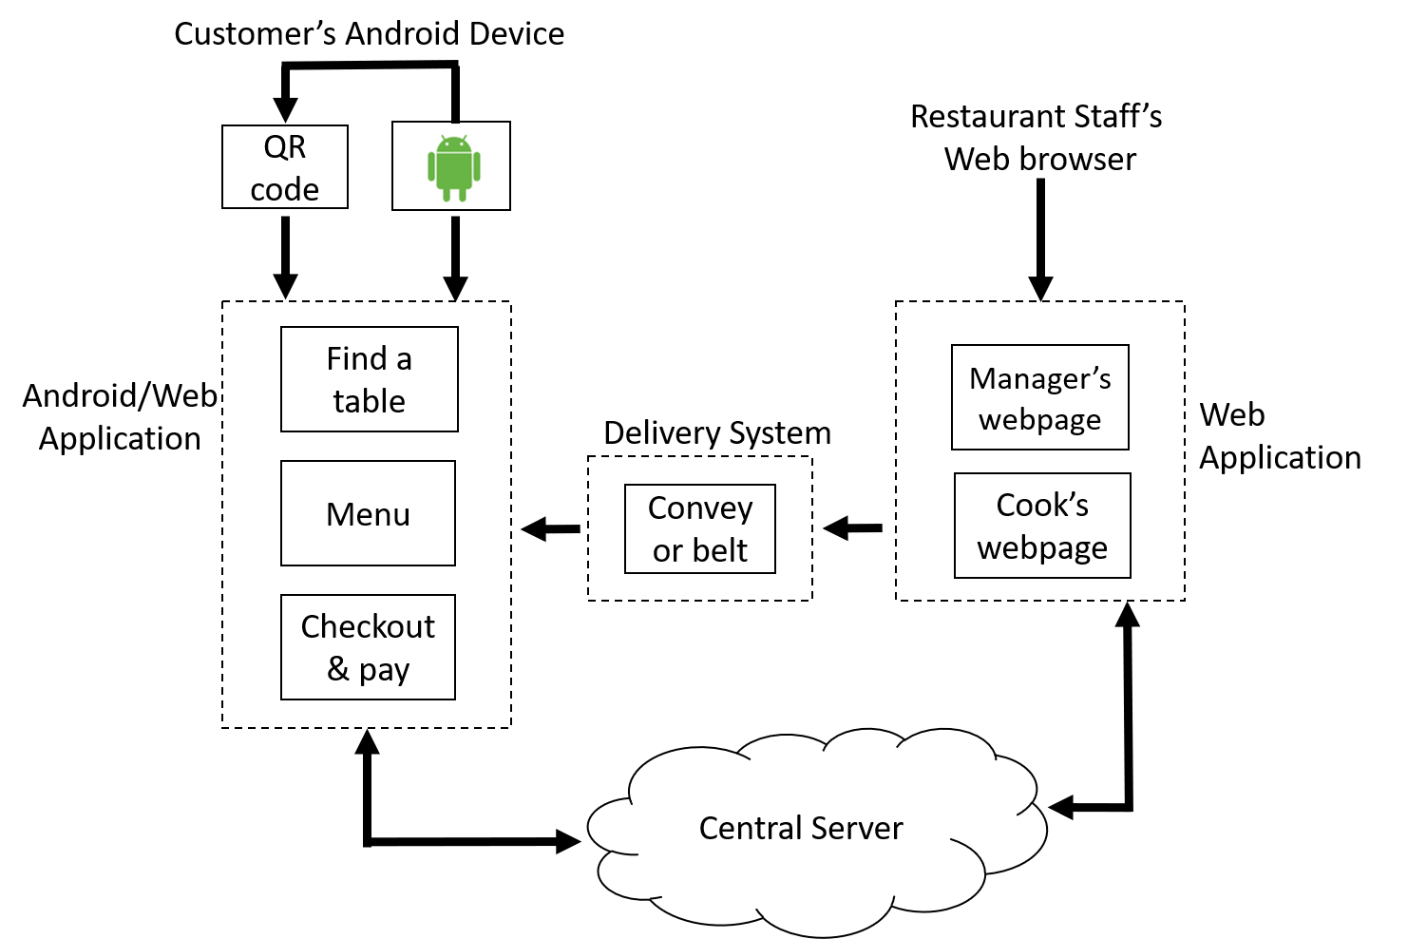

**REQUIREMENTS:**

Software:

* Android Studio
* QR code Generator
* Atom
* HTML
* Java Script
* Cascading style sheets

Hardware:

* Raspberry pi 3
* PIR sensor
* 2 DC Motors
* Conveyor belts
* Smart Tablets
* Wireless Router
* LCD Display
* Desktop

**TEST PROCEDURES:**

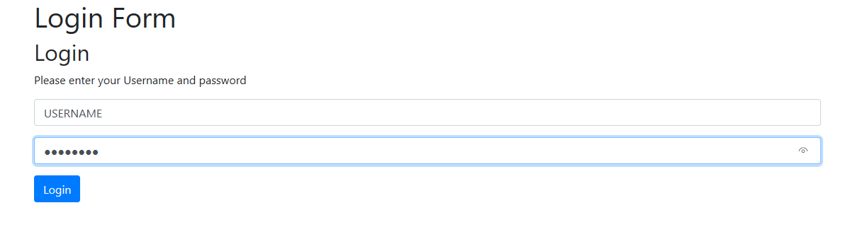

**Fig 1 Login details**

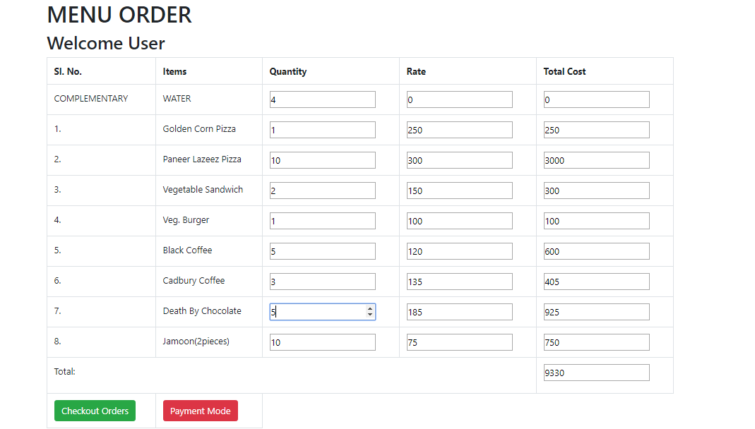

**Fig 2 Menu order**

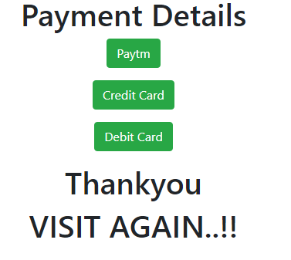 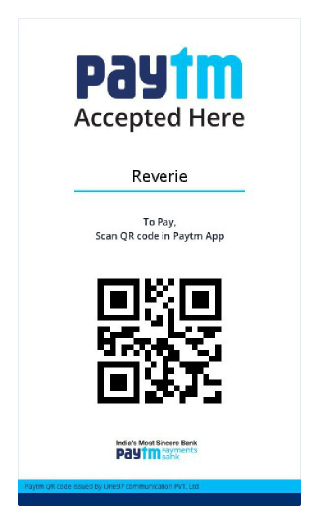

**Fig 3 Payment details Fig 4 Paytm payment**

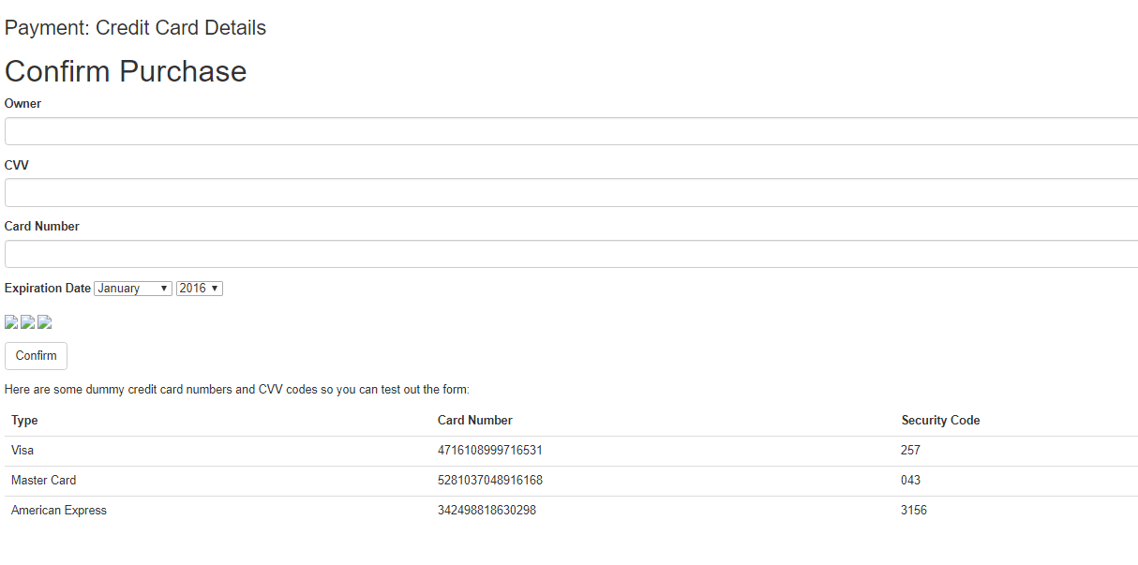

**Fig 5 Credit card details**

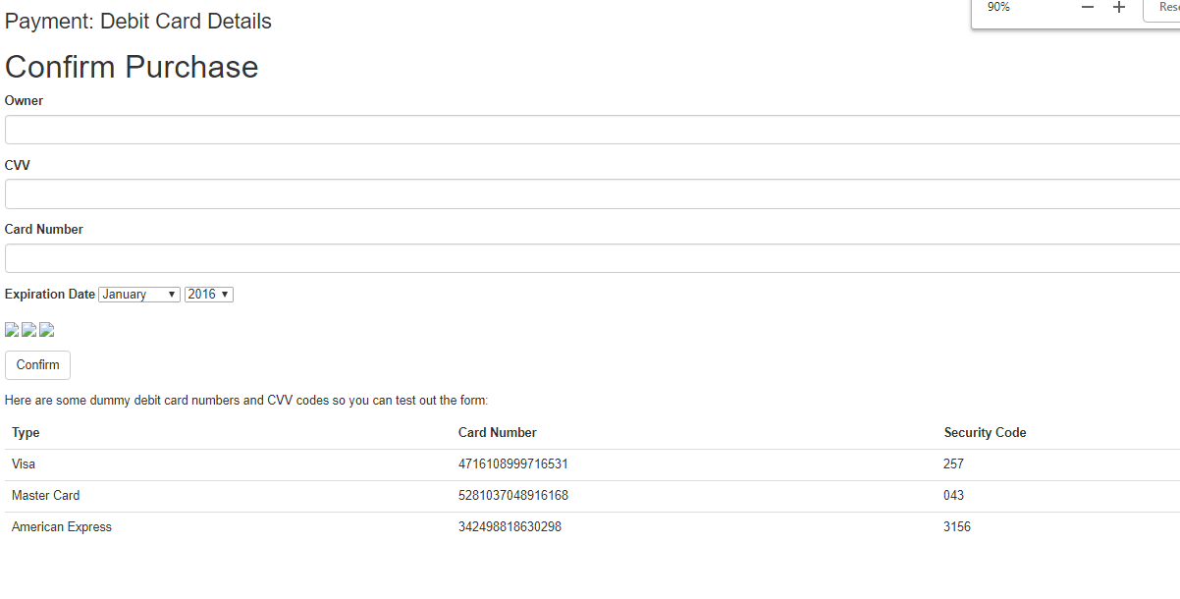

**Fig 6 Debit card details**

* User login details, Menu order, Payment mode and different payment samples detail images are shown.
* URL is linked to QR code, upon scanning the code Image 1 appears which access the user information. After login details menu cart appears which access the menu information.
* After placing the order different modes of payment options are provided.
* Checkout orders are notified.

**EXPECTED OUTPUT:**

* Design of automated menu ordering and delivery of order to the customer table in restaurants.
* Able to store customer’s information and menu information.
* The system has a friendly user interface.
* System takes order from the customer as per his/her choice.
* The system calculates and displays the final bill based on the placed order.
* The delay in ordering of food in a fully packed restaurant can be overcome.

**REFERENCES:**

* Smart Restaurant 1Mrs. Bindu Sebastian, 2Athira Varghese, 3Megha Merin Jose 1,2,3 ECE Department, Vimal Jyothi Engineering College,Kannur.
* Jeetender Singh Chauhan, Sunil Semwal," Microcontroller Based Speed Control of DC Geared Motor Through RS-232 Interface With PC ", International Journal of Engineering Research and Applications(IJERA) Vol. 3, Issue 1, January -February 2013, pp.778-783.
* LINEAR INTEGRATED CIRCUITS:- Dr. ROY CHOUDHARY, SHAIL .D. JAIN
* N. M. Z. Hashim “Smart Ordering System via Bluetooth” in International Journal of Computer Trends and Technology (IJCTT) – volume 4 Issue 7–Month 2013
* Near-Field Communication Sensors and Cloud-Based Smart Restaurant Management System by Hassain Saeed, Ali Shouman, Mais Elfar, Mostafa Shabka, Shikharesh Majumdar, Chung Horng-Lung